Remembrance 2021?

Hi
I am Brad Oliver Scottish organiser for VfPUK.
I served in the UK army for 5 years in the 1970s

There’s nothing wrong in remembrance, in fact it’s to be encouraged!
It’s the way that remembrance is commemorated that needs to be discussed and explored.

There is no need to decorate a Jet fighter with an image of a poppy [image]
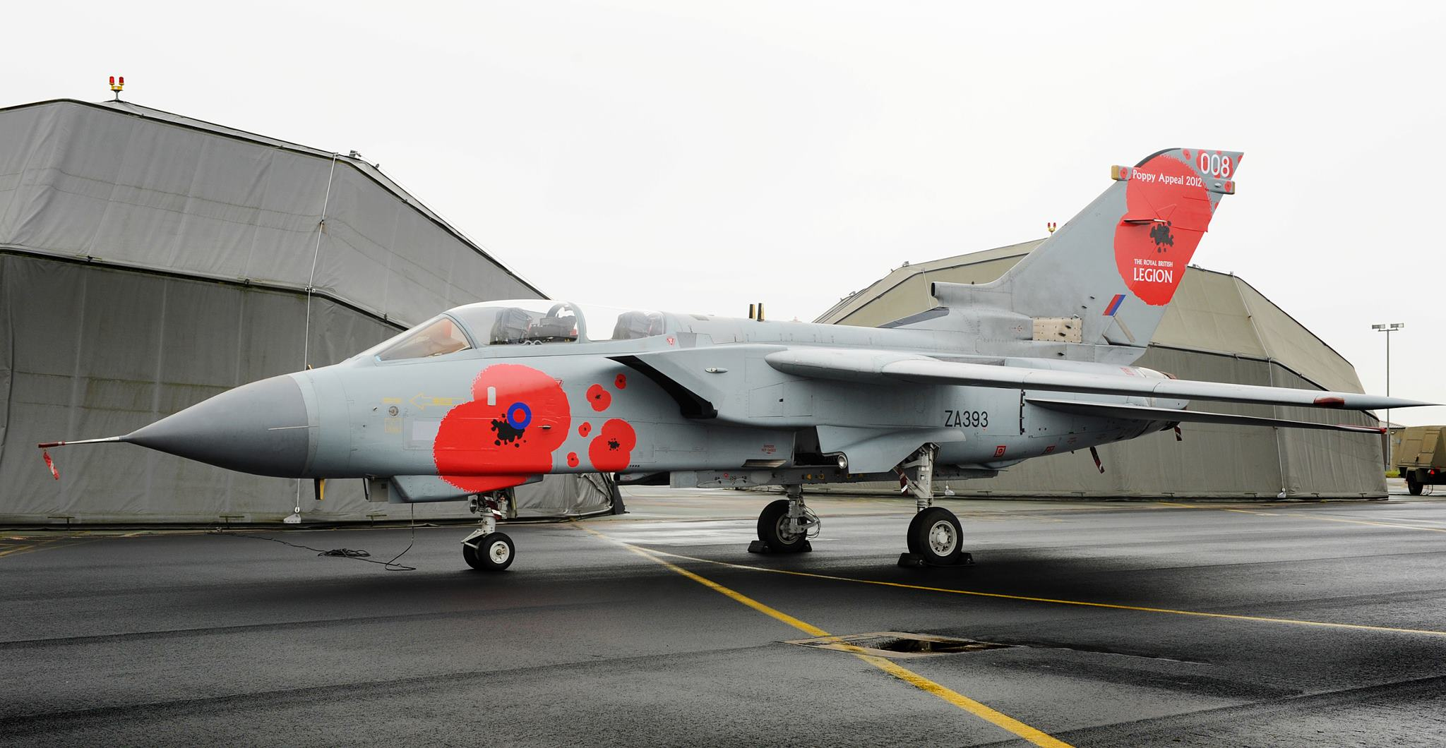
Lets bomb while we remember !

Also, there is no need to drop poppies from a WW2 bomber
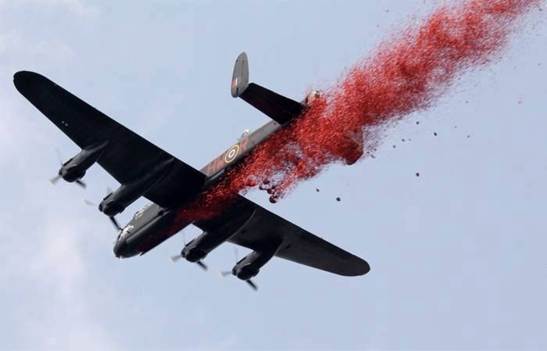

To me this is blood of the 20 million + who died in WW2.

Or to bedeck the Tower of London with poppies.

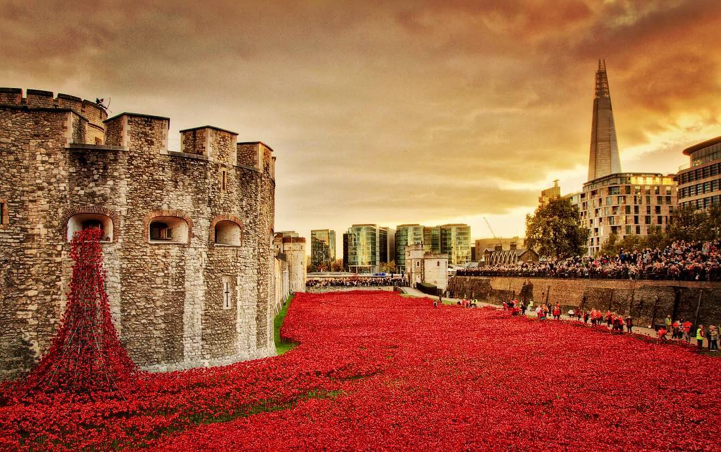

Or a gunshot wound in the shape of a Poppy! my personal least favourite.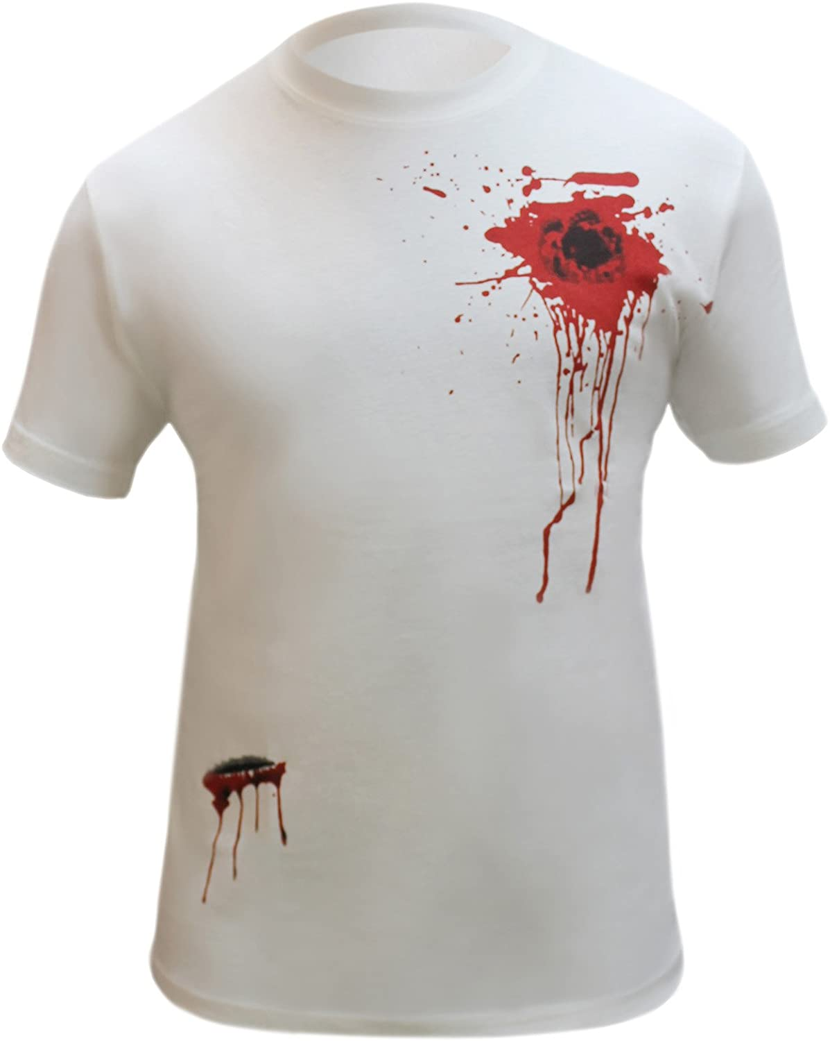

Then we have the so called “celebrity’s” trying to outdo each other as to who can wear their poppy first and who has the most garish Ott poppy on their lapel, whose manufacture gives only 10% to RBL. Charity.
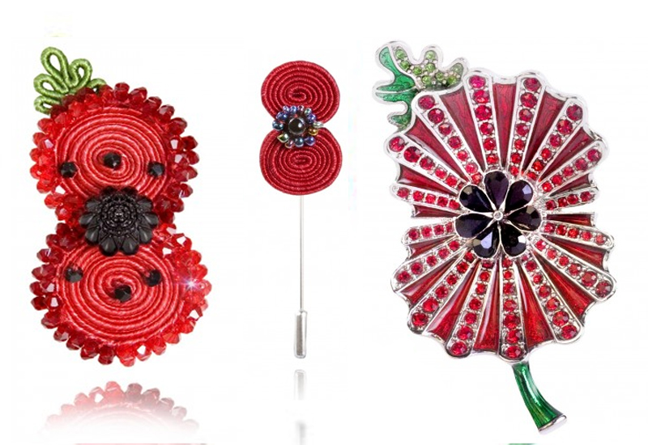

When I visited Palestine/Israel I walked along some of the Apartheid wall and met a guy who spoke English, I chatted to him about things and the wall I said it was nice that people had painted nice images on the wall. He rebuked me strongly, stating that we don’t want the wall to look nice as it is an ugly wall and an ugly idea to isolate people from each other.

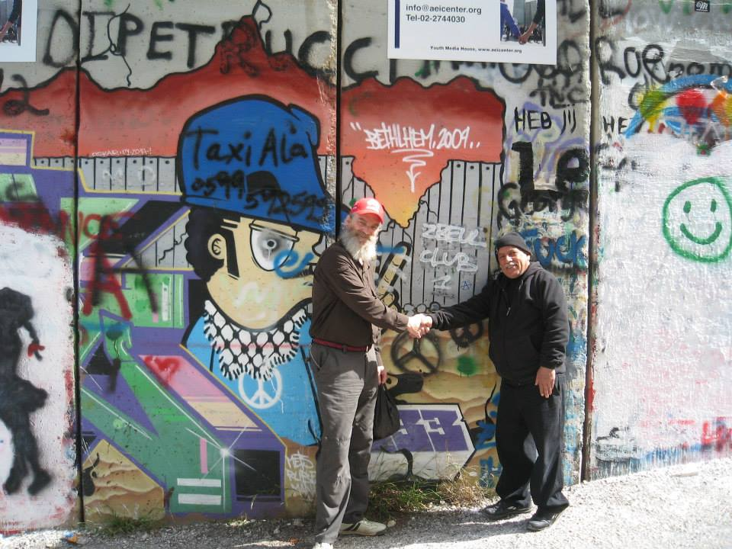

This is now my view of the modern-day poppy it has been “white washed” to look beautiful with art installations and events to “celebrate”. There is nothing to celebrate in war only its ending!

The original poppy was a symbol from WW1 where nothing grew except the poppy in the Dante’s hell that was Flanders/Somme etc.
Over the years it has become a fund-raising emblem for ex services charity, there should be NO ex-services charities. The government put those service people in harm’s way so the government should pay for their care and rehabilitation.

When I watched the remembrance parades in the early 60s as child it was mostly what I would call citizens army e.g., the majority of WW2 guys were conscripts either willing or otherwise.
These guys [mostly guys} didn’t think they were heroes they were just fighting fascism in Europe. A fight that may be rerun in years to come?

When I was growing up, WW2 was basically all around, my grandad on my mother’s side had died in WW2, my grandad on my father’s side was a sub mariner {not a job I would like to do}
In my innocent 5-year-old brain I thought that eventually there would not be any veterans marching past the Cenotaph, little did I realise that there were already thousands of veterans from Korea and Britain’s colonial exit strategy wars in, Palestine, Malaya, Aden and Suez to name but a few.
In recent years the numbers at the cenotaph have swollen on Remembrance Day with the veterans from N. Ireland the 30 years [police action} in the “Troubles”. The Malvinas/Falklands, Bosnia, and Gulf war 1 and 2 and good old Afghanistan a country Faught Over by imperialist powers for 200 years.

In the last 25 to 30 years the poppy has become more and more politicised manly by the right and the far right.
With footballers and newsreaders etc having death threats given against them for not wearing the poppy.

The very war Faught for freedom dictates that wearing of a poppy is your freedom of choice and not a dictate from a totalitarian state. So, the guys who died for freedom are being dishonoured by the poppy fascists who demand people wear a poppy to show “respect”

The far right and the main stream media has jumped on the band wagon sending out false news re Muslim areas banning the poppy etc whilst the far right give the Hitler salute whilst wearing a poppy.
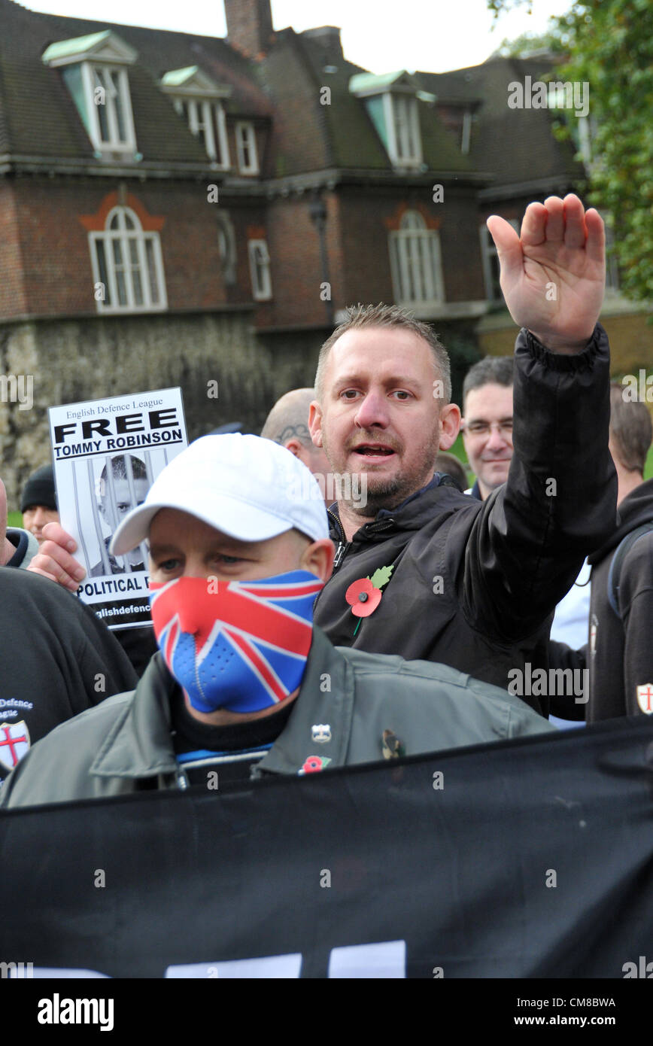
Fascists wearing a poppy! Would that be called an oxymoron or just a moron?

The truth is that as its significance fades Remembrance Sunday has become less an anthem for doomed youth and ever more a celebration of a wider, mostly male, seemingly infinite obsession with the two wars. The second conflict may have ended over 70 years ago but you wouldn’t know it. WWII is everywhere: it’s on the telly, it’s in our cinemas, it’s on our minds and on our lips more than might be healthy.
When terrorist incidents happen, or the bus is delayed, we talk about “The Blitz Spirit” or “The Dunkirk Spirit”. [I bet in Germany or Hiroshima they don’t say the bombing spirit?] No matter that none of the people invoking it were even there. No matter that equating a late bus to the carpet bombing of a city is just plain dumb.
The poppy has gone from a small act of remembrance to a virtual whip that is deployed to beat non-conformists into line.
The vocabulary used by politicians and news pundits does not lend its self to the promotion of peace.
Things like surrender monkey French, traitors, the enemy etc etc.
I will always remember the Thatcher “government” saying that the striking miners who were only trying to save their job as “the enemy within “

Let is now look at the power behind the throne so to speak!
The Royal British Legion, on paper an organisation supposably dedicated to veterans’ charity?
The shift in both the presentation and significance of the ‘poppy’, and its increasing use by the Legion not “just” to remember past wars but to be actively co-opted in order to advocate support for current and future wars - “support for our troops”, “proper respect for the Armed Forces” - is part of a much wider shift towards militarism in this country, as many commentators and organisations have noticed. Quaker Peace & Social Witness (QPSW), in their remarkable document ‘The New Tide of Militarism’, have documented this new presentation of militarism, and how it is being developed: “there is a new and different tide of militarisation that has developed over the last five years. The general public do not seem to be aware of it, and it is not being discussed or scrutinised.”
As they suggest, our general lack of awareness of this “new and different tide of militarism” is due to the subtlety and care with which it is being introduced, and the unexpected forms it takes. As QPSW note, “The involvement of the military in the Royal British Legion’s campaign has also increased. Whereas in the past the role was mainly to participate in the ceremonies around Remembrance Day, now troops and cadets sell poppies”, often with the cry of “Support our troops!”.

The 2008 Government report ‘National Recognition of our Armed Forces’ aimed to eliminate the “separation of the Armed Forces from civilian life”, which it seeks to do through such means as: encouraging “a greater relationship between the military and the media”; fostering “greater engagement between Parliament and the military”; increasing the presence of the military in schools through expansion of the Combined Cadet Forces (CCF); “to do everything possible to encourage more comprehensive Schools and City .
This is the worrying thing getting “troops” into schools something that happened in 1930s Germany.

Today, poppies are sold on railway stations by current forces personnel calling, ‘Support the troops?’ Surely the poppy cannot carry both meanings without contradiction” These contradictions only deepen when you start to investigate the extensive links between the British Legion and contemporary arms companies.
Many of these policies are enabled by the weaponry that BAE Systems, the platinum sponsor of the British Legion Poppy Appeal, supplies. As CAAT research shows, “Saudi Arabia is the largest buyer of UK weapons in the world.” It adds, “It is also one of the worst human rights abusers.” BAE Systems armoured vehicles were used by Saudi troops to suppress pro-democracy protests in Bahrain in 2011.

Indeed, BAE has had an extensive history of sales involvement with the Saudi dictatorships and was at the centre of one of the biggest arms trade scandals ever: the notorious £43billion ‘Al-Yamamah’ (the word means ‘dove’ - arms traders, it seems, are not without a sense of irony) deal with Saudi Arabia in the 1980s. In the words of the Financial Times, this arms deal was “the biggest [UK] sale ever of anything to anyone.”, It included not only sales of extensive weaponry but also training and advice for the Saudi military.
The deal eventually led to BAE Systems being sentenced to pay a $400 million criminal fine, one of the largest criminal fines in the history of the international arms trade. As the Guardian noted, “BAE admitted to false accounting and making misleading statements. The company ran a global money laundering system: a network of secret cash payments amounting to billions of pounds that went on for years with the connivance of the British government.
In 2003, the Royal British Legion chose this company to be their major financial sponsor for their Festival of Remembrance.

An annual military uniform fetish ball!
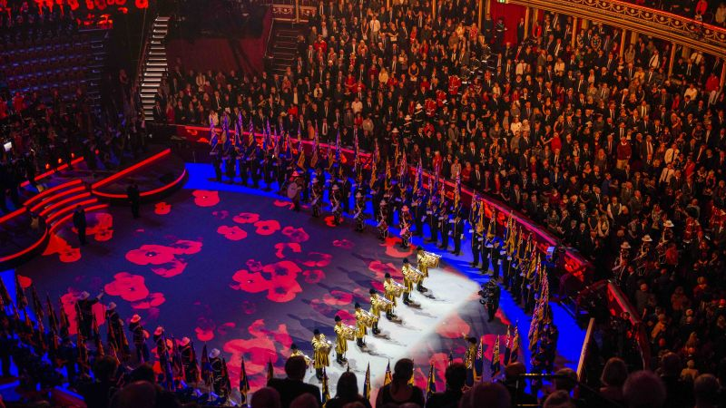

We are forgetting one of the major drivers of the First World War, and indeed of all wars: the arms market. “The British arms company Vickers-Armstrong, later to become BAE, sold arms to the Ottoman Empire that were used later against British troops, this points us again to the curious process through which poppies are worn to commemorate soldiers killed by weapons made by arms companies which sponsor the manufacture of poppies which are worn to commemorate!!!!

The words we use to describe warfare and killing profoundly shape how we think about them. This is why governments, arms companies, and the media have become skilled in how they speak about war. As Orwell noted, we must be wary of their lexicons of doublethink: “Political language is designed to make lies sound truthful and murder respectable, and to give an appearance of solidity to pure wind.”
We are all familiar with this duplicitous language of making murder respectable: “collateral damage” (the slaughter of innocents), “friendly fire” (having a fellow-soldier accidentally blow your face off), “extraordinary rendition” (illegal torture), “dynamic room entries” (blowing up your front door in the middle of the night). But equally insidious and sanitising are the words routinely marched out on Armistice Day to cover the shocking and often unnecessary slaughter of men and women in the armed forces today: “sacrifice”, “heroes”, “the fallen”. As one veteran noted, “Why do we call them “the fallen”? It’s not as if they just fell over.

The re taking of remembrance.
In recent years there has been a light at the end of the tunnel namely Veterans for Peace UK.
Who have organised alternative events to remember the slaughter of all wars and all casualty’s whether military or civilian?

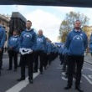
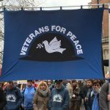

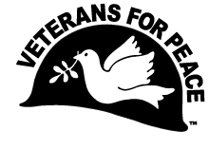

We, veterans of the armed forces, having dutifully served our nation, do hereby affirm our greater responsibility to serve the cause of world peace. To this end:
a. We will work toward increasing public awareness of the costs of war.
b. We will work to restrain our government from intervening, overtly and covertly, in the internal affairs of other nations
c. We will work to end the arms race and to reduce and eventually eliminate nuclear weapons.
To achieve these goals, members of Veterans for Peace pledge to use non-violent means and to maintain an organisation that is both democratic and open with the understanding that all members are trusted to act in the best interests of the group for the larger purpose of world peace.
We urge all veterans who share this vision to join us.

